

# Bharati Vidyapeeth’s

**Institute of Management & Information Technology**

# C.B.D. Belapur, Navi Mumbai 400614

## Vision:

Providing high quality, innovative and value-based education in information technology to build competent professionals.

## Mission

M1. Technical Skills:-To provide solid technical foundation theoretically as well as practically capable of providing quality services toindustry.

M2. Development: -Department caters to the needs of students through comprehensive educational programs and promotes lifelong learning in the field of computer Applications.

M3. Ethical leadership:-Department develops ethical leadership insight in the students to succeed in industry, government and academia.

**CERTIFICATE**

This is to certify that the journal is the work of

Mr. Pratham Anil Vichare Roll No. 65 of MCA

(Sem- 1  Div:A) Batch: A3 for the academic year 2023 - 2024

Subject Code: MCAL14

Subject Name: Web Technology Lab

________________ _____________

Subject-in-charge Principal

Date:

_______________

External Examiner

Date:

**INDEX**

|  |  |  |
| --- | --- | --- |
| **Sr No.** | **Topic** | **Sign** |
| **1** | **Nodejs Module** |  |
| 1.1 | Create an application to demonstrate Node.js Modules. |  |
| **2** | **Events** |  |
| 2.2 | Create an application to demonstrate various Node.js Events. |  |
| 2.3 | Implement all Methods of EventEmitter class. |  |
|  | Create an application to demonstrate Node.js Functions |  |
| **3** | **File System and HTTP Server** |  |
| 3.1 | Create an HTTP Server and perform operations on it. |  |
| 3.2 | Using File Handling demonstrate all basic file operations (Create, write, read, delete) |  |
| **4** | **MySQL database connectivity.** |  |
| 4.1 | Create an application to establish a connection with the MySQL database and perform basic database operations on it. |  |
| **5** | **AngularJs** |  |
| 5.1 | Write a program in AngularJs of expression for operators and variables . |  |
| 5.2 | Write a program in AngularJs of expression contains any two data type. |  |
| 5.3 | Write a program in AngularJs of expression for arithmetic operators which will produce the result based on the type of operands. |  |
| 5.4 | Write a program in AngularJs which demonstrates handling click event of a button |  |
| 5.5 | Write a program in AngularJs for scope object where controller available to the HTML elements and its child elements |  |
| 5.6 | Write a program in AngularJs demonstrates multiple controllers. |  |
| 5.7 | Write a program in AngularJs to demonstratesng-init directive for string, number, array, and object. |  |
| 5.8 | Write a program in AngularJs to demonstrates ng-if, ng-readonly, and ng- disabled directives. |  |
| 5.9 | Write a program in AngularJs for currency filter to person salary. |  |
| 6.0 | Write a program in AngularJs demonstrates Date filter. |  |
| 6.1 | Write a program in AngularJs upper case and lowercase filter |  |
| 6.2 | Write a program in AngularJs to demonstrates mouse event |  |

1. **Nodejs Module**

**1.1 Create an application to demonstrate Node.js Modules.**

**1. Hello World**

|  |
| --- |
| console.log("Hello World"); |

**Output:**

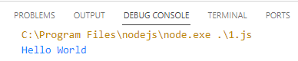

**2. Multiplication**

|  |
| --- |
| function myfun(x,y)  {  return x*y;  }  console.log (myfun(2,5)); |

**Output:**

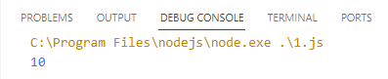

**3. Fibonacci**

|  |
| --- |
| function myfun(num1,num2)  {  console.log(num1+num2);  console.log(num1-num2);  console.log(num1*num2);  console.log(num1/num2);  }  myfun(12,3); |

**Output:**

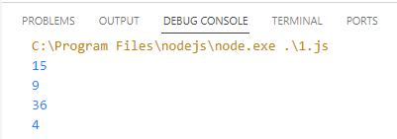

**4. Callback Function**

|  |
| --- |
| const message=function(){ console.log("Hi I am Sainath");  }  setTimeout(message,3000);  setTimeout(()=>{console.log("Calling from arrow function");  },3000); |

**Output:**

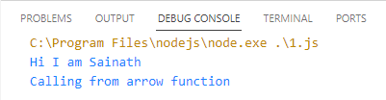

**5. Javascript callback**

|  |
| --- |
| function displayresult(some)  {      console.log(some);  }  function calculate(x,y,mycallback)  {      let sum=x+y;      mycallback(sum);  }  calculate(5,10,displayresult); |

**Output:**

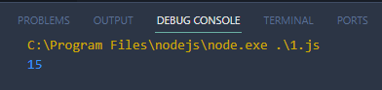

**6. Block Code**

|  |
| --- |
| var fs=require('fs');  var data=fs.readFileSync('input.txt');  console.log(data.toString());  console.log("program ended") |

**Output:**

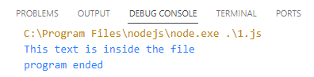

**7. Non Block code**

|  |
| --- |
| var fs=require('fs');  fs.readFile("input.txt",function(err,data){      if(err)      {          return console.error(err);      }      console.log(data.toString());  });  console.log("program ended"); |

**Output:**

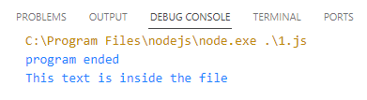

**2. Events**

**2.1 Create an application to demonstrate various Node.js Events.**

|  |
| --- |
| // step 1 importing event  const events = require("events");  // step 2 creating an Event emitter object  const eventEmitter = new events.EventEmitter();  //write a function of event 1  function listner1() {      console.log("Event recevied by Listner 1");  }  //write a function of event 2  function listner2() {      console.log("Event recevied by Listner 2");  }  // step 3 adding listener through addlistener or on  eventEmitter.addListener("write", listner1);  eventEmitter.on("write", listner2);  // step 4 emiting event  eventEmitter.emit("write");  console.log(eventEmitter.listenerCount("write"));  // step 5  removing listener  eventEmitter.removeListener("write", listner1);  console.log("Listener 1 is removed");  eventEmitter.emit("write");  console.log(eventEmitter.listenerCount("write"));  console.log("Program Ended"); |

**Output:**

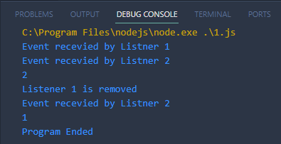

**2.2 Implement all Methods of EventEmitter class.**

|  |
| --- |
| const events = require("events");  const eventEmitter = new events.EventEmitter();  eventEmitter.on("connection", handleConnectionEvent);  eventEmitter.emit("connection");  eventEmitter.emit("connection");  eventEmitter.emit("connection");  eventEmitter.emit("connection");  function handleConnectionEvent() {      console.log("Conneciton Made!");  }  console.log("End of Program"); |

**Output:**

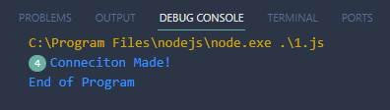

**2.3 Create an application to demonstrate Node.js Functions.**

|  |
| --- |
| // understand http request module  var http = require('http'); // 1 - Import Node.js core module  var server = http.createServer(function (req, res) {   // 2 - creating server      //handle incomming requests here..      res.write("Hello Server");      res.end();  });  server.listen(5000); //3 - listen for any incoming requests  console.log('Node.js web server at port 5000 is running..') |

Output:

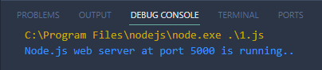

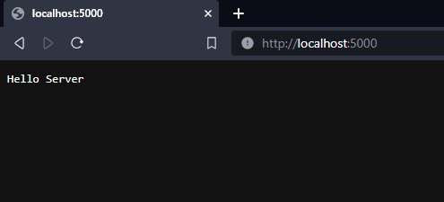

**3. File System and HTTP Server**

**3.1 Create an HTTP Server and perform operations on it.**

|  |
| --- |
| //understand routing in http module  var http = require('http'); // Import Node.js core module  var server = http.createServer(function (req, res) {   //create web server      if (req.url == '/') { //check the URL of the current request          // set response header          res.writeHead(200, { 'Content-Type': 'text/html' });          // set response content          res.write('<html><body><p>This is home Page.</p></body></html>');          res.end();      }      else if (req.url == "/student") {          res.writeHead(200, { 'Content-Type': 'text/html' });          res.write('<html><body><p>This is student Page.</p></body></html>');          res.end();      }      else if (req.url == "/admin") {          res.writeHead(200, { 'Content-Type': 'text/html' });          res.write('<html><body><p>This is admin Page.</p></body></html>');          res.end();      }      else          res.end('Invalid Request!');  });  server.listen(5000); //6 - listen for any incoming requests  console.log('Node.js web server at port 5000 is running..') |

Output:

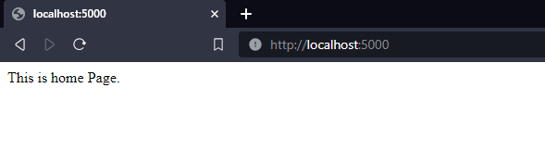

**3.2 Using File Handling demonstrate all basic file operations (Create, write, read, delete)**

|  |
| --- |
| //Writing file  var fs = require('fs');  fs.writeFile('test.txt', 'Hello World!', function (err) {          if (err)              console.log(err);          else          console.log('Write operation complete.');  });  fs.readFile('test.txt', function (err, data) {      if (err) throw err;  console.log(data.toString());  });  fs.unlink('test.txt', function () {        console.log('delete operation complete.');  }); |

**Output:**

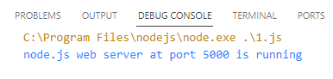

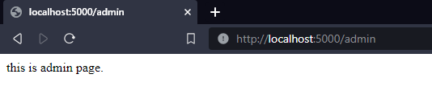

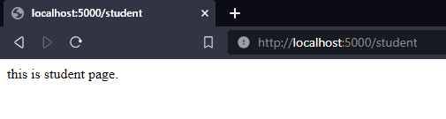

**>> Reading a file**

|  |
| --- |
| var fs = require('fs');  fs.readFile('input.txt', function (err, data) {      if (err) throw err; console.log(data.toString());  }); |

**Ouput:**

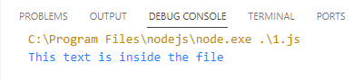

**>>Write to File**

|  |
| --- |
| var fs = require('fs');  fs.writeFile('test.txt', 'Hello World!', function (err) {      if (err)          console.log(err); else          console.log('Write operation complete.');  }); |

**Output:**

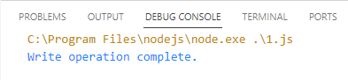

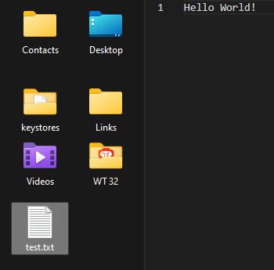

**>>Update the file**

|  |
| --- |
| var fs = require('fs');  fs.appendFile('test.txt', ' Hey Hello', function (err) {      if (err) throw err;      console.log('Updated!');  }); |

**Output:**

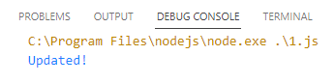



**>> Rename**

|  |
| --- |
| var fs = require('fs');  fs.rename('input.txt', 'myrenamedfile.txt', function (err) {      if (err) throw err;      console.log('File Renamed!');  }); |

**Output:**

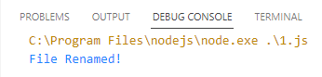

**>>Delete the file**

|  |
| --- |
| var fs = require('fs');  fs.unlink('myrenamedfile.txt', function (err) {      if (err) throw err;      console.log('File deleted!');  }); |

**Output:**

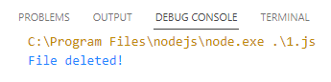

**>> Buffer**

|  |
| --- |
| var fs = require('fs');  fs.open('test.txt', 'r', function (err, fd) {      if (err) {          return console.error(err);      }      var buffr = new Buffer(10240); fs.read(fd, buffr, 0, buffr.length, 0, function (err, bytes) {          if (err) throw err; if (bytes > 0) {              console.log(buffr.slice(0, bytes).toString());          }          fs.close(fd, function (err) {              if (err) throw err;          });      });  }); |

**Output:**

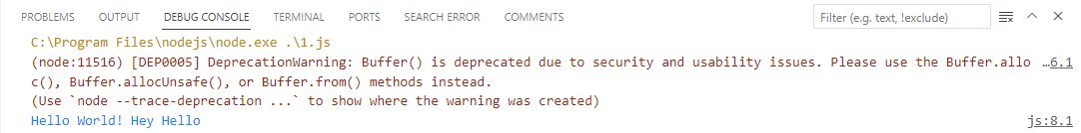

**4. MySQL database connectivity.**

**4.1 Create an application to establish a connection with the MySQL database and perform basic database operations on it.** 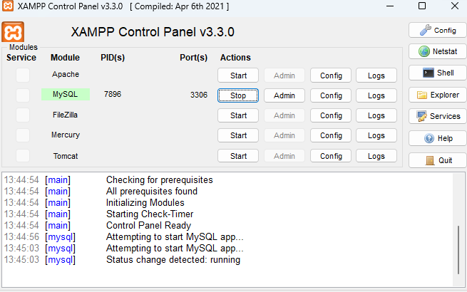

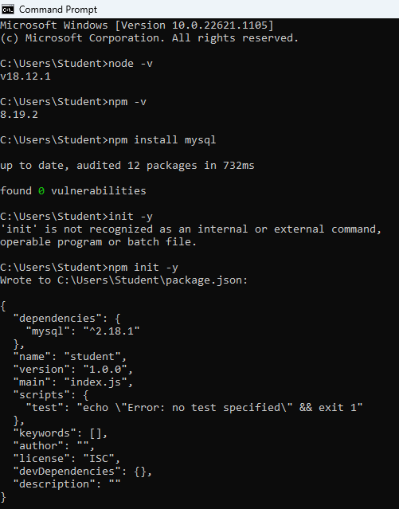

**Creating database**

|  |
| --- |
| var mysql = require('mysql');  var con = mysql.createConnection({      host: "localhost", user: "root",      password: ""  });  con.connect(function (err) {      if (err) throw err; console.log("connected!");      con.query("create database mydb1", function (err, result) {          if (err) throw err;          console.log("Database created");      });  }); |

**Output:**

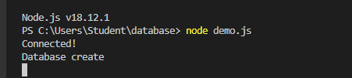

**Creating Table**

|  |
| --- |
| var mysql = require('mysql');  var con = mysql.createConnection({      host: "localhost",      user: "root",      password: "", database: "mydb1"  })  con.connect(function (err) {      if (err) throw err;      console.log("Connected!");      var sql = "CREATE TABLE cutomers11 (name VARCHAR(255),address VARCHAR(255))";      con.query(sql, function (err, result) {          if (err) throw err; console.log("Table creates");      });  }); |

**Output:**

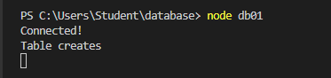

**Primary Key**

|  |
| --- |
| var mysql = require('mysql');  var con = mysql.createConnection({      host: "localhost",      user: "root",      password: "", database: "mydb01"  })  con.connect(function (err) {      if (err) throw err;      console.log("Connected!");      var sql = "CREATE TABLE cutomers01 (id int auto_increment primary key,name VARCHAR(255),address VARCHAR(255))";      con.query(sql, function (err, result) {          if (err) throw err; console.log("Table creates");      });  }); |

**Output:**

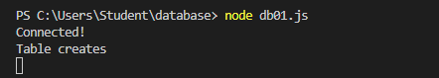

**Connectivity**

|  |
| --- |
| var mysql = require('mysql');  var con = mysql.createConnection({      host: "localhost",      user: "root",      password: "", database: "mydb01"  })  con.connect(function (err) {      if (err) throw err;      console.log("Connected!");  }); |

**Output:**

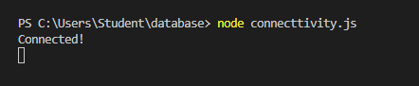

**Insertion**

|  |
| --- |
| var mysql = require('mysql');  var con = mysql.createConnection({      host: "localhost", user: "root",      password: "", database: "mydb1"  });  con.connect(function (err) {      if (err) throw err; console.log("connected!");      var sql = "Insert INTO customers21 (name,address) VALUES ('company inc','Highway 32')";      var sql = "Insert INTO customers21 (name,address) VALUES ('company ltd','Highway Glory')";      var sql = "Insert INTO customers21 (name,address) VALUES ('citypride','under the sky')";      con.query(sql, function (err, result) {          if (err) throw err;          console.log("1 record inserted");      });  }); |

**Output:**



**Reading Data**

|  |
| --- |
| var mysql = require('mysql');  var con = mysql.createConnection({      host: "localhost",      user: "root",      password: "",      database: "mydb01"  });  con.connect(function (err) {      if (err) throw err;      console.log("Connected!");      var sql = "INSERT INTO cutomers01 (name, address) VALUES ('Company st','Highway 05')";      var sql = "INSERT INTO cutomers01 (name, address) VALUES ('Company pvi','Highway NH06')";      var sql = "INSERT INTO cutomers01 (name, address) VALUES ('Service Inc','High street')";      con.query(sql, function (err, result) {          if (err) throw err;          console.log("1 record inserted");      });  }); |

**Output:**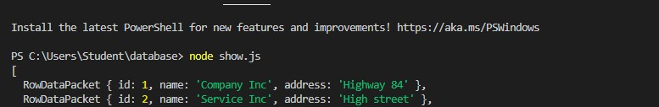

**Update**

|  |
| --- |
| var mysql = require('mysql');  var con = mysql.createConnection({      host: "localhost",      user: "root",      password: "", database: "mydb01"  });  con.connect(function (err) {      if (err) throw err;      var sql = "UPDATE cutomers01 SET address = 'canyon' WHERE address = 'Highway 84'";      con.query(sql, function (err, result) {          if (err) throw err;          console.log(result.affectedRows + "record(s) updated");      });  }); |

**Output:**

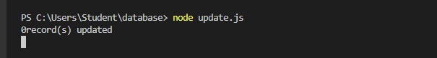

**After Update**



**Delete**

|  |
| --- |
| var mysql = require('mysql');  var con = mysql.createConnection({      host: "localhost",      user: "root",      password: "", database: "mydb01"  });  con.connect(function (err) {      if (err) throw err;      var sql = "DELETE FROM cutomers01 WHERE address = 'High street'"; con.query(sql, function (err, result) {          if (err) throw err;          console.log("Number of records deleted: " + result.affectedRows);      });  }); |

**Output:**

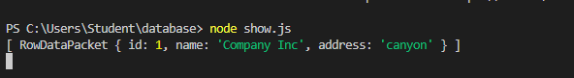

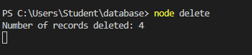

**5. AngularJs**

**5.1 Write a program in AngularJs of expression for operators and variables.**

|  |
| --- |
| <!DOCTYPE html>  <html >  <head>      <script src="https://ajax.googleapis.com/ajax/libs/angularjs/1.8.2/angular.min.js"></script>  </head>  <body >      <h1>AngularJS Expression Demo:</h1>      <div ng-app>          2 + 2 = {{2 + 2}} <br />          2 - 2 = {{2 - 2}} <br />          2 * 2 = {{2 * 2}} <br />          2 / 2 = {{2 / 2}}      </div>  </body>  </html> |

Output:

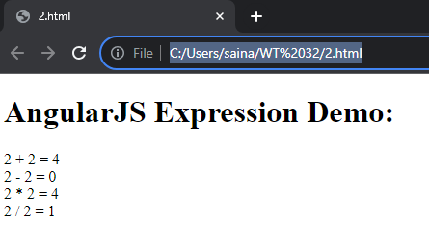

**5.2 Write a program in AngularJs of expression contains any two data type.**

|  |
| --- |
| <html >  <head>      <script src="https://ajax.googleapis.com/ajax/libs/angularjs/1.8.2/angular.min.js"></script>  </head>  <body >      <h1>AngularJS Expression Demo:</h1>      <div ng-app>          {{"Hello World"}}<br />          {{100}}<br />          {{true}}<br />          {{10.2}}      </div>  </body>  </html> |

Output:

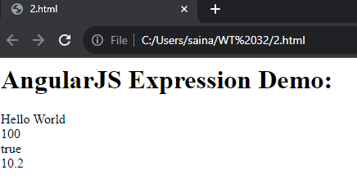

**5.3 Write a program in AngularJs of expression for arithmetic operators which will produce the result based on the type of operands**

|  |
| --- |
| <!DOCTYPE html>  <html >  <head>      <script src="https://ajax.googleapis.com/ajax/libs/angularjs/1.8.2/angular.min.js"></script>  </head>  <body >      <div ng-app>          {{"Hello" + " World"}}<br />          {{100 + 100 }}<br />          {{true + false}}<br />          {{10.2 + 10.2}}<br />      </div>  </body>  </html> |

Output:

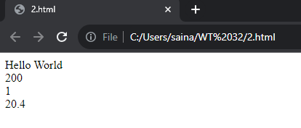

**5.4 Write a program in AngularJs which demonstrates handling click event of a button**

|  |
| --- |
| <!DOCTYPE html>  <html >  <head>      <script src="https://ajax.googleapis.com/ajax/libs/angularjs/1.8.2/angular.min.js"></script>  </head>  <body ng-app="myApp">      <div ng-controller="myController">          Enter Password: <input type="password" ng-model="password" /> <br />            <button ng-click="DisplayMessage(password)">Show Password</button      </div>      <script>          var myApp = angular.module('myApp', []);            myApp.controller("myController", function ($scope, $window) {                $scope.DisplayMessage = function (value) {                  $window.alert(value)              }          });      </script>  </body>  </html> |

Output:

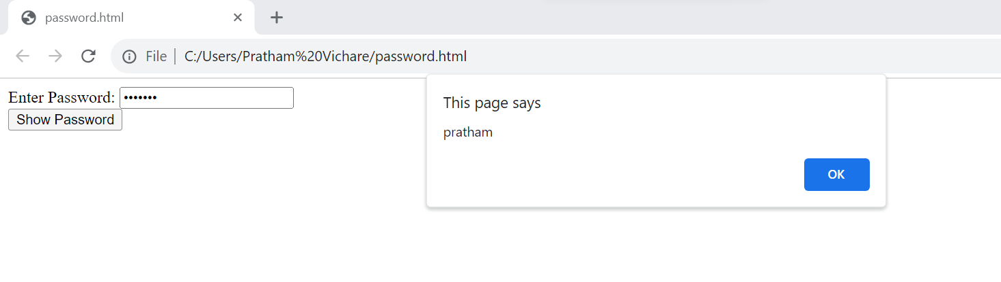

**5.5 Write a program in AngularJs for scope object where controller available to the HTML elements and its child elements**

|  |
| --- |
| <!DOCTYPE html>  <html>  <head>      <title>AngualrJS Controller</title>      <script src="https://ajax.googleapis.com/ajax/libs/angularjs/1.8.2/angular.min.js"></script>  </head>  <body ng-app="myNgApp">      <div ng-controller="parentController">          Message: {{message1}}          <div ng-controller="childController">              Parent Message: {{message1}}  </br>              Child Message: {{message2}}          </div>          Child Message: {{message2}}      </div>      <script>           var ngApp = angular.module('myNgApp', []);          ngApp.controller('parentController', function ($scope) {              $scope.message1 = "This is parentController";          });          ngApp.controller('childController', function ($scope) {              $scope.message2 = "This is childController";          });      </script>  </body>  </html> |

Output:

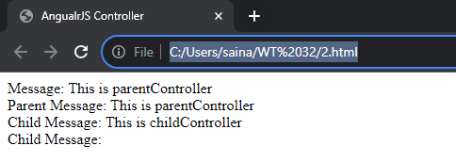

**5.6 Write a program in AngularJs demonstrates multiple controllers.**

|  |
| --- |
| <!DOCTYPE html>  <html>  <head>      <title>AngualrJS Controller</title>      <script src="https://ajax.googleapis.com/ajax/libs/angularjs/1.8.2/angular.min.js"></script>  </head>  <body ng-app="myNgApp">      <div id="div1" ng-controller="myController">          Message: {{message}} <br />          <div id="div2">              Message: {{message}}          </div>      </div>      <div id="div3">          Message: {{message}}      </div>      <div id="div4" ng-controller="anotherController">          Message: {{message}}      </div>      <script>          var ngApp = angular.module('myNgApp', []);          ngApp.controller('myController', function ($scope) {              $scope.message = "This is myController";          });          ngApp.controller('anotherController', function ($scope) {              $scope.message = "This is anotherController";          });      </script>  </body>  </html> |

Output:

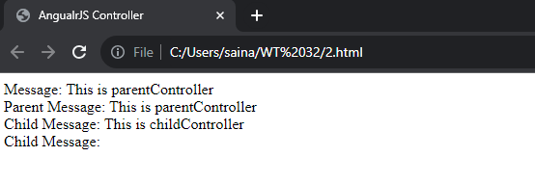

**5.7 Write a program in AngularJs to demonstratesng-init directive for string, number, array, and object.**

|  |
| --- |
| <!DOCTYPE html>  <html >  <head>      <script src="https://ajax.googleapis.com/ajax/libs/angularjs/1.8.2/angular.min.js"></script>  </head>  <body >      <div ng-app ng-init="greet='Hello World!'; amount= 100; myArr = [100, 200]; person = { firstName:'Steve', lastName :'Jobs'}">          {{amount}}      <br />          {{myArr[1]}}    <br />          {{person.firstName}}      </div>  </body>  </html> |

**Output:**

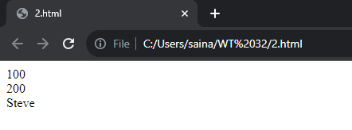

**5.8 Write a program in AngularJs to demonstrates ng-if, ng-readonly, and ng- disabled directives.**

|  |
| --- |
| <!DOCTYPE html>  <html>  <head>  <script src="https://ajax.googleapis.com/ajax/libs/angularjs/1.8.2/angular.min.js"></script>  <style>  div {  width: 100%;  height: 50px;  display: block;  margin: 15px 0 0 10px;  }  </style>  </head>  <body ng-app ng-init="checked=true" >  Click Me: <input type="checkbox" ng-model="checked" /> <br />  <div>  New: <input ng-if="checked" type="text" />  </div>  <div>  Read-only: <input ng-readonly="checked" type="text" value="This is read-only." />  </div>  <div>  Disabled: <input ng-disabled="checked" type="text" value="This is disabled." />  </div>  </body>  </html> |

**Output:**

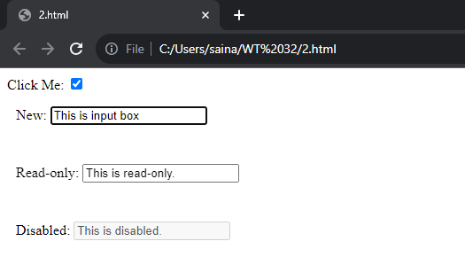

**5.9 Write a program in AngularJs for currency filter to person salary.**

|  |
| --- |
| <!DOCTYPE html>  <html >  <head>  <script src="https://ajax.googleapis.com/ajax/libs/angularjs/1.8.2/angular.min.js"></script>  </head>  <body ng-app="myApp">  <div ng-controller="myController">  Default currency: {{person.salary | currency}} <br />  Custom currency identifier: {{person.salary | currency:'Rs.'}} <br />  No Fraction: {{person.salary | currency:'Rs.':0}} <br />  Fraction 2: <span ng-bind="person.salary| currency:'GBP':2"></span>  </div>  <script>  var myApp = angular.module('myApp', []);    myApp.controller("myController", function ($scope) {  $scope.person = { firstName: 'James', lastName: 'Bond', salary: 100000}  });  </script>  </body>  </html> |

**Output:**

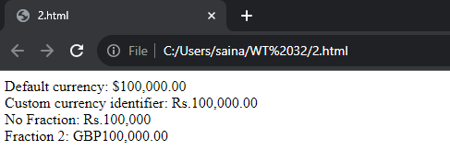

**6.0 Write a program in AngularJs demonstrates Date filter.**

|  |
| --- |
| <!DOCTYPE html>  <html >  <head>      <script src="https://ajax.googleapis.com/ajax/libs/angularjs/1.8.2/angular.min.js"></script>  </head>  <body ng-app>      <div ng-init="person.DOB = 323234234898">          Default date: {{person.DOB| date}} <br />          Short date: {{person.DOB| date:'short'}} <br />          Long date: {{person.DOB | date:'longDate'}} <br />          Year: {{person.DOB | date:'yyyy'}} <br />      </div>  </body>  </html> |

**Output:**

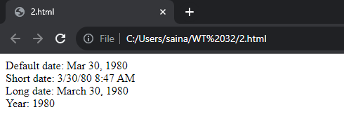

**6.1 Write a program in AngularJs upper case and lowercase filter**

|  |
| --- |
| <!DOCTYPE html>  <html >  <head>  <script src="https://ajax.googleapis.com/ajax/libs/angularjs/1.8.2/angular.min.js"></script>  </head>  <body ng-app>  <div ng-init="person.firstName='Sainath';person.lastName='Machha'">  Lower case: **{{**person.firstName + ' ' + person.lastName | lowercase**}}** <br />  Upper case: **{{**person.firstName + ' ' + person.lastName | uppercase**}}**  </div>  </body>  </html> |

**Output:**

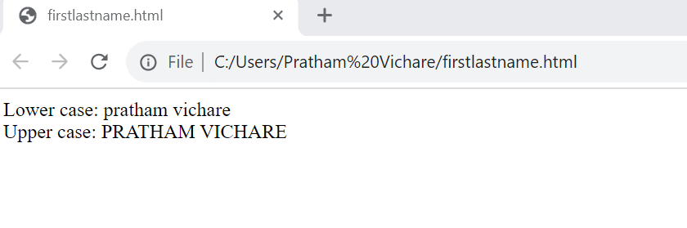

**6.2 Write a program in AngularJs to demonstrates mouse event**

|  |
| --- |
| <!DOCTYPE html>  <html>  <head>      <script src="https://ajax.googleapis.com/ajax/libs/angularjs/1.8.2/angular.min.js"></script>      <style>          .redDiv {              width: 100px;              height: 100px;              background-color: red;              padding:2px 2px 2px 2px;          }          .yellowDiv {              width: 100px;              height: 100px;              background-color: yellow;              padding:2px 2px 2px 2px;          }      </style>  </head>  <body ng-app>          <div ng-class="{redDiv: enter, yellowDiv: leave}" ng-mouseenter="enter=true;leave=false;" ng-mouseleave="leave=true;enter=false">              Mouse <span ng-show="enter">Enter</span> <span ng-show="leave">Leave</span>          </div>  </body>  </html> |

**Output:**

